# Introduction

Toronto, Canada is one of the most diverse cities in the world [1] and consists of many immigrants from all over the world. People of Asian origins account for about 17.7% of Canadian population as per the 2016 census report.[1] From this overall Asian community, South Asians are considered a visible minority in Canada as per the classification of Statistics Canada[2] and are growing at a substantial pace due to the new immigration programs such as Express Entry.

Food culture in Toronto is as diverse as its population. As the South Asian population grow so does the demand for South Asian food. Sri Lanka is an island nation in the Indian ocean and has a unique cuisine inspired by Indian, Portuguese, Dutch and south-east Asian cuisines.

## Business Problem

Determining a place to open a Sri Lankan restaurant (for that matter any restaurant) should be done after carefully considering the market size, demand and the penetration capabilities. This project seeks to understand the data and insights surrounding Toronto in order to determine suitable neighborhoods in Toronto, Canada to open a Sri Lankan Restaurant

In other words, the busines problem that I try to answer is **“What neighborhood(s) is/are most suitable to open a Sri Lankan cuisine restaurant in the city of Toronto, in Canada?”**

## Target Audience and stakeholders

This project is intended for two main groups of individuals or organizations, namely, investors who are exploring opportunities to step into the restaurant business and current restaurant owners planning to expand or diversify their business into different cuisines and neighborhoods.

# Data

The data section discusses about the data sets and the data sources considered for this project. All data in this project are publicly available data sourced through world wide web and Canadian government data portals and reports.

## Data sources

### Toronto Neighborhood Data

Toronto city officially has 140 neighborhoods covering multiple districts of old Toronto, East York, Etobicoke, North York, Scarborough and York. There are multiple ways of dividing the neighborhoods for different purposes but for the scope of this project I will be using the City Designated Neighborhoods (CDN) as the reference for each neighborhood.

The 140 neighborhood division according to CDN is available in Wikipedia page at, (<https://en.wikipedia.org/wiki/List_of_neighbourhoods_in_Toronto#Table>).

This neighborhood data is then geocoded to obtain a longitude and latitude value for each neighborhood which then can be used to search for restaurant venues in that neighborhood.

A sample geocoded neighborhood data set looks like this.

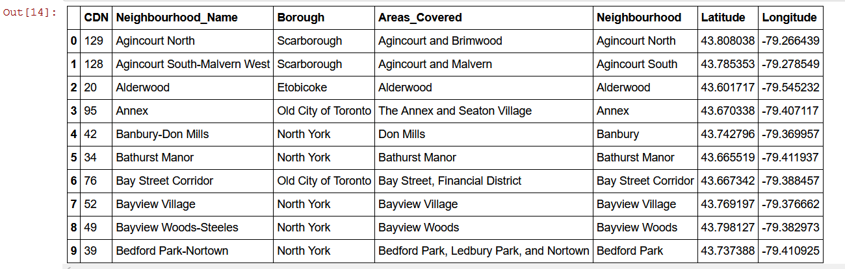

### Neighborhood Demographic data

It is important to understand the demographics of each neighborhood in this study and hence I used the Statistics Canada 2016 census reports to obtain the population data end ethnic origin data for each neighborhood. A CSV file was downloaded and processed to extract he necessary dataset.

The link to the Statistics Canada page is,

<https://www12.statcan.gc.ca/census-recensement/2016/dp-pd/prof/details/page_Download-Telecharger.cfm?Lang=E&Tab=1&Geo1=CSD&Code1=3520005&Geo2=PR&Code2=01&SearchText=toronto&SearchType=Begins&SearchPR=01&B1=All&TABID=1&type=0>

A sample data set extracted from the CSV file looks like this.

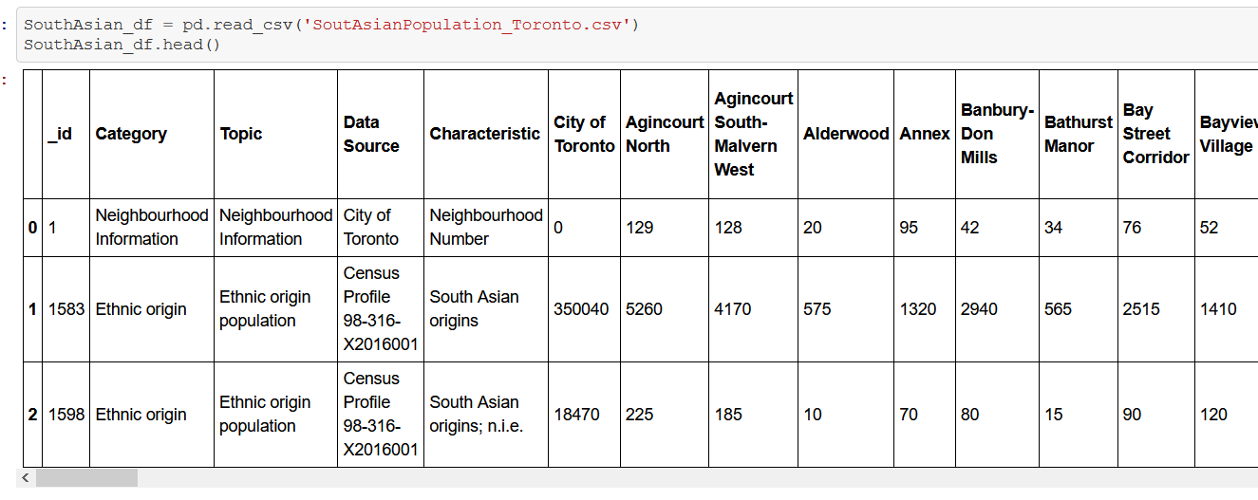

### Current Restaurant (venue category) data

Foursquare is one of the largest data sources when it comes to location-based venue data and is free to use (with certain limitations) with a developer account. Foursquare is used to obtain the venue categories of each venue located within a given radius of the neighborhood. A sample dataset from the Foursquare service (after some preparation and cleaning ) looks like this.

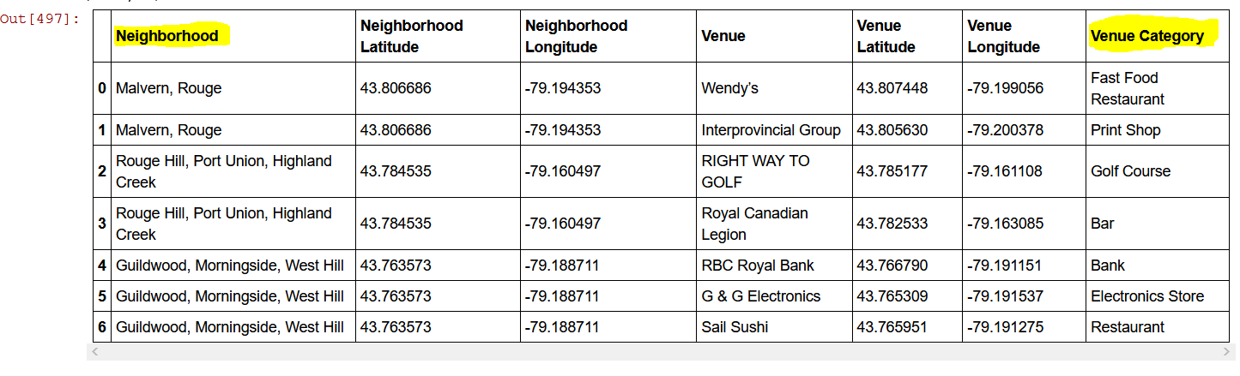

# References

[1] https://www.worldatlas.com/articles/the-most-diverse-cities-in-the-world.html

[2] <https://www12.statcan.gc.ca/census-recensement/2016/dp-pd/prof/details/page.cfm?Lang=E&Geo1=PR&Code1=01&Geo2=PR&Code2=01&Data=Count&SearchText=canada&SearchType=Begins&SearchPR=01&B1=Ethnic%20origin&TABID=1>

[3] <https://web.archive.org/web/20160718232555/http://www.statcan.gc.ca/eng/concepts/definitions/minority01a>

Neighbourhoods Wikipedia page:

<https://en.wikipedia.org/wiki/List_of_neighbourhoods_in_Toronto#Table>

Postal codes:

<https://en.wikipedia.org/wiki/List_of_postal_codes_of_Canada:_M>